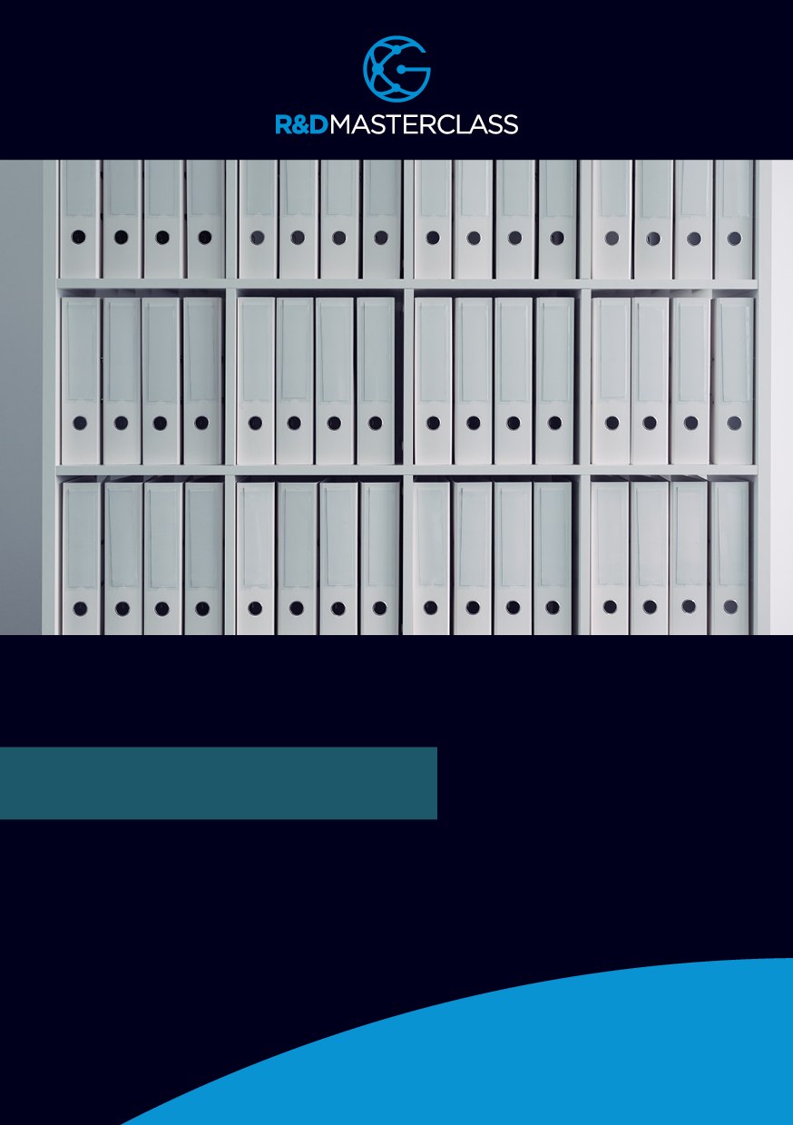

R&D Plan.docx

**R&D PLAN**

r&d proforma plan

TABLE OF CONTENTS

R&D Plan for the Financial Year 3

Part A: Authorization 3

Part B: Detailed Project Plans 4

INSERT Company Details and Logo Here

# R&D Plan for the Financial Year

## Part A: Authorization

It has been determined that the following R&D projects will be actioned by the company during the financial year.

|  |  |
| --- | --- |
| **PROJECT NAME** | **HOW DOES THIS PROJECT SUPPORTS THE STRATEGIC BUSINESS OBJECTIVES OF THE COMPANY?** |
| **1:** |  |
| **2:** |  |
| **3:** |  |
| **Etc.** |  |

Approved by: The Board - XZY Pty Ltd ACN 000 000 000

You may want to amend this to be an “authorized officer of the company” which also is acceptable Name Position and Date required.

Signed Director ­­­­­­­­­­­­­­­­­­­­­­­­­­­­­­­­­_____________________________

Signed Secretary _____________________________

Date xx/xx/202x

## Part B: Detailed Project Plans

|  |  |
| --- | --- |
| **PROJECT 1:** *<INSERT TITLE>* | **DESCRIPTION/REFERENCE LINK** |
| * the date when the Plan was prepared or last updated |  |
| * the background information, including the reasons for undertaking the project and a description of how the project will enhance the commercial success of the company |  |
| * a statement of the technical objective or specific technical aim of the project |  |
| * relevant timelines or Gantt charts covering major activities and milestones forming part of the project |  |

**NB. REPEAT THE ABOVE PROCESS FOR EACH NEW PROJECT**

Signed: _______________________________________

Date: XX/XX/202x

Notes:

Here is a repository for Company records.

1. R&D Proforma Plan

R&D Application Form - this will be undertaken at the end of the FY (unless applying for an Advanced Finding)

1. R&D Registration Letter - this is provided at the end of the FY
2. R&D Tax Schedule - this is provided at the end of the FY
3. Contracts and Agreements relating to R&D Projects:

a. Suppliers & Clients showing Company meets On Own Behalf Criteria

b. Claimant Owns Intellectual Property

c. Research Service Provider Agreements

d. Cooperative Research Centre Agreements

e. Foreign Parent Agreements

f. Grant providers

1. Advice by R&D Tax Consultants regarding eligibility

